Ex No:1 | PASSPORT AUTOMATION SYSTEM
Date:

USE CASE DIAGRAM:
This diagram will contain the actors, use cases which are given below
Actors: Applicant, Enquiry Officer.
Use case: Applicant details, Applicant proof, Verification of proof, Issue of passport, Cancellation of the passport.

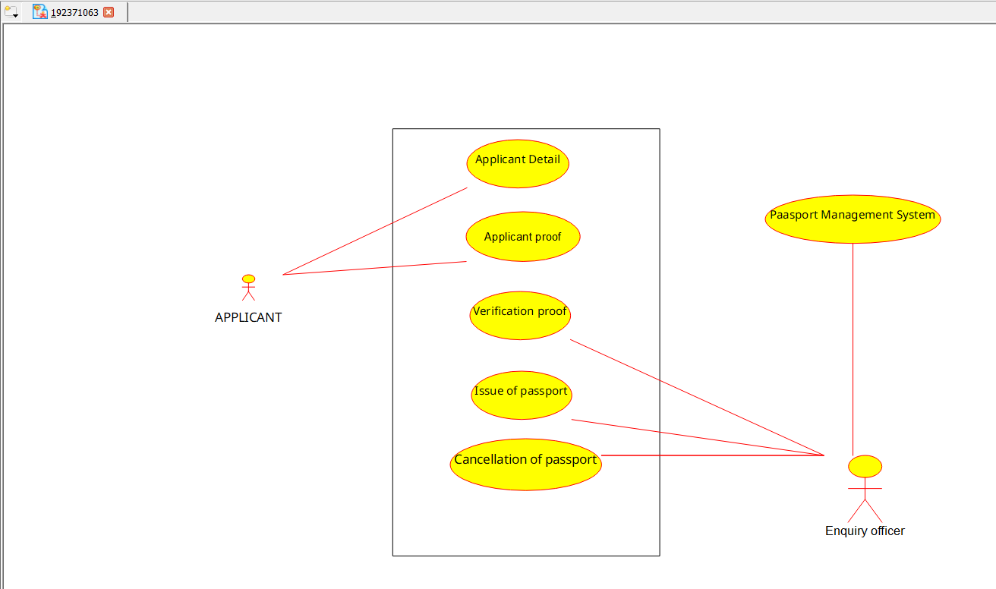

CLASS DIAGRAM:
This diagram consists of the following classes, attributes and their operations.
CLASSES | ATTRIBTES | OPERATIONS
Passport management system | Verify details, Store proof | Verification of proof()
Enquiry officer | Applicant details | Issue of passport()
Applicant | Name, Details | Apply passport()

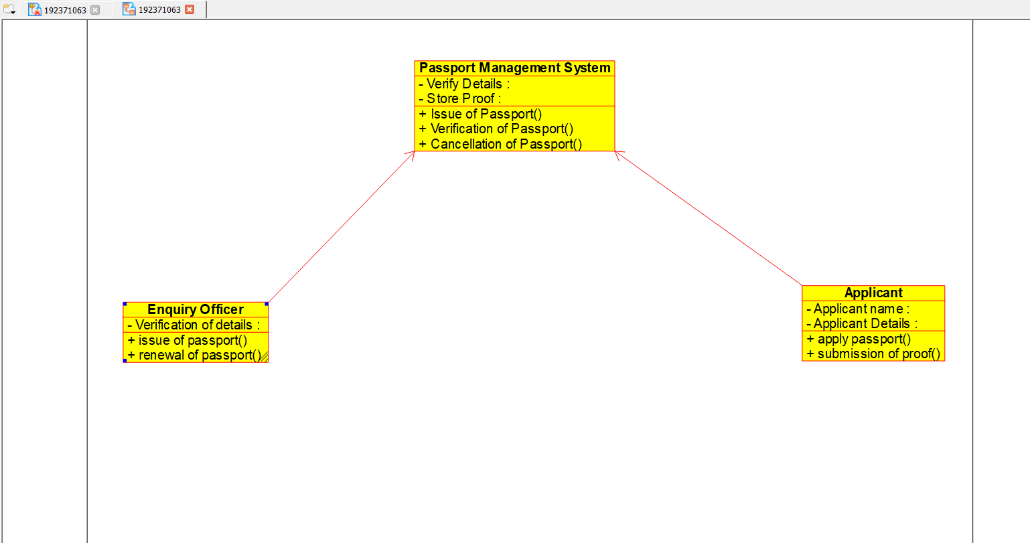

ACTIVITY DIAGRAM:
This diagram will have the activities as Start point, End point, Decision boxes as given below:
Activities: Enter applicant details, Submission of proof, Verification of details, Issue of passport.
Decision box: Check details whether it is correct or not.
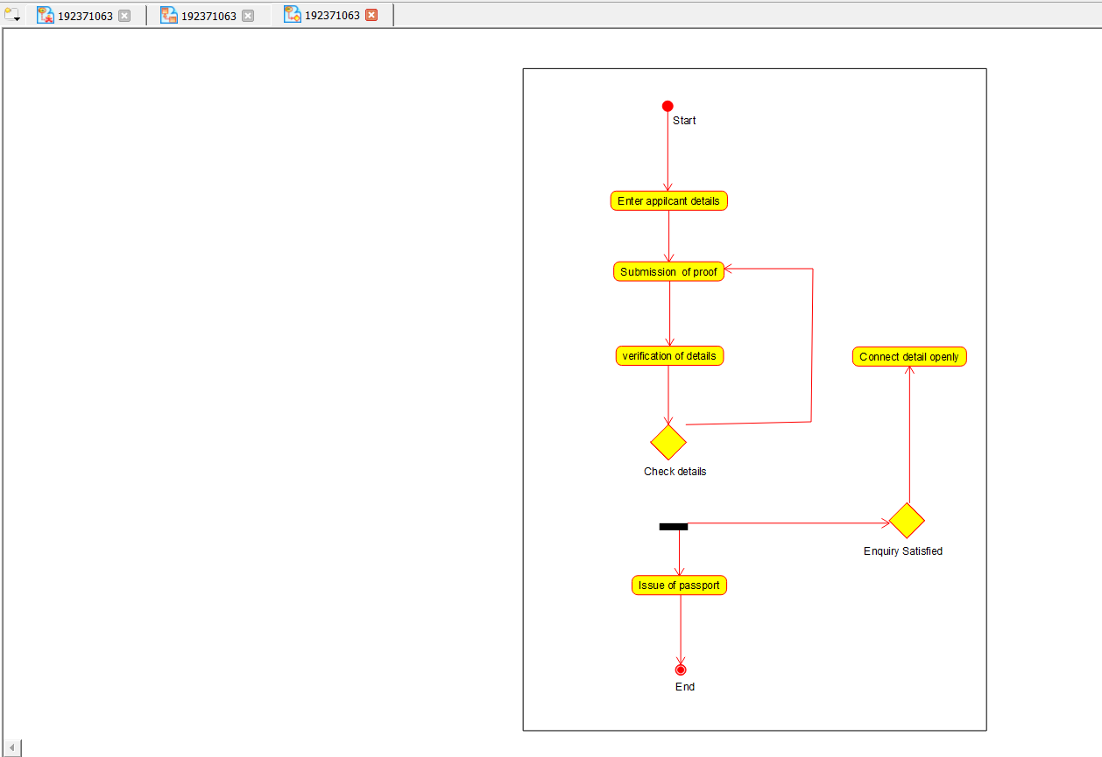

SEQUENCE DIAGRAM:
This diagram consists of the objects, messages and return messages.
Object: Applicant, Enquiry officer, Passport management system.

COLLABORATION DIAGRAM:
This diagram contains the objects and actors. This will be obtained by the completion of the sequence diagram and pressing the F5 key.

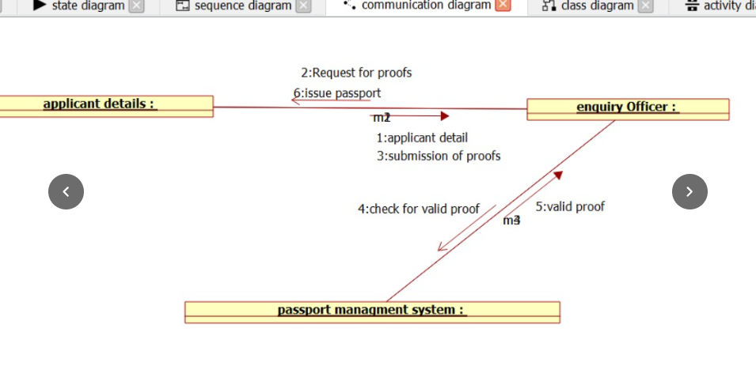

STATE CHART DIAGRAM :
The purpose of state chart diagram is to understand the algorithm involved in performing a method. It is also called as state diagram. A state is represented as a round box, which may contain one or more compartments. An initial state is represented as small dot. An final state is represented as circle surrounding a small dot.

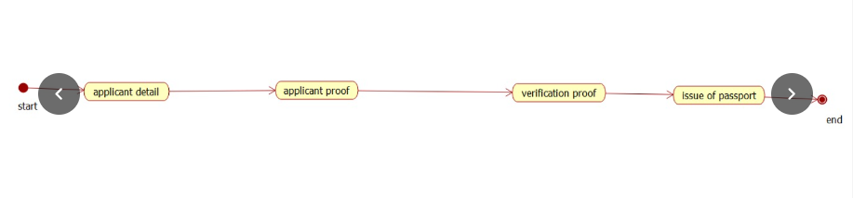

COMPONENT DIAGRAM
The component diagram's main purpose is to show the structural relationships between the components of a system. It is represented by boxed figure. Dependencies are represented by communication association.
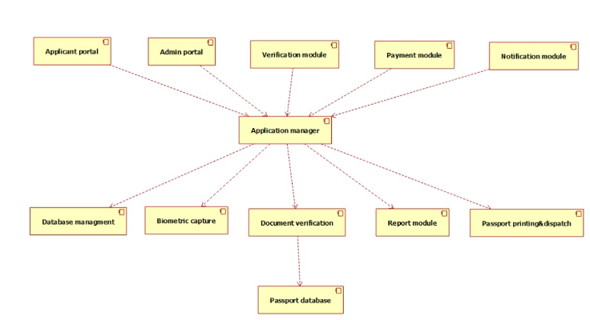

DEPLOYMENT DIAGRAM
A deployment diagram in the unified modeling language serves to model the physical deployment of artifacts on deployment targets. Deployment diagrams show "the allocation of artifacts to nodes according to the Deployments defined between them. It is represented by 3- dimentional box. Dependencies are represented by communication association.
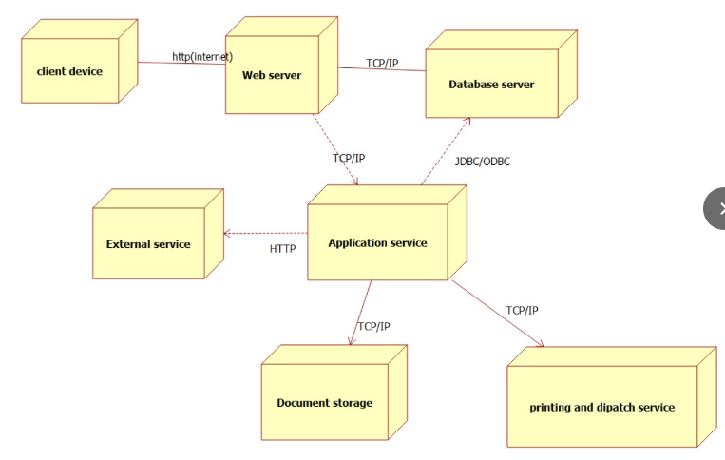

PACKAGE DIAGRAM:
A package diagram in unified modeling language that depicts the dependencies between the packages that make up a model. A Package Diagram (PD) shows a grouping of elements in the OO model, and is a Cradle extension to UML. PDs can be used to show groups of classes in Class Diagrams (CDs), groups of components or processes in Component Diagrams (CPDs), or groups of processors in Deployment Diagrams (DPDs).
There are three types of layer. They are
o User interface layer

o Domain layer

o Technical services layer
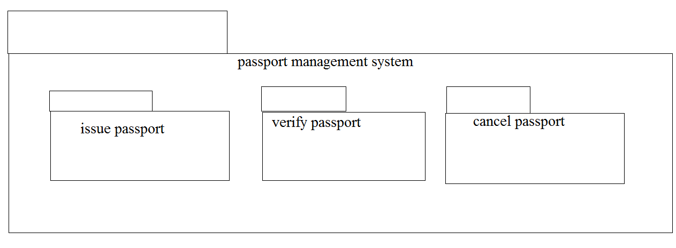
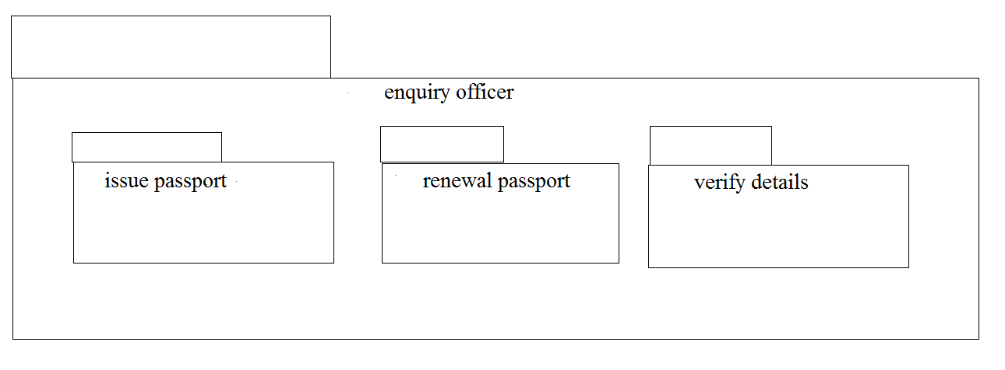

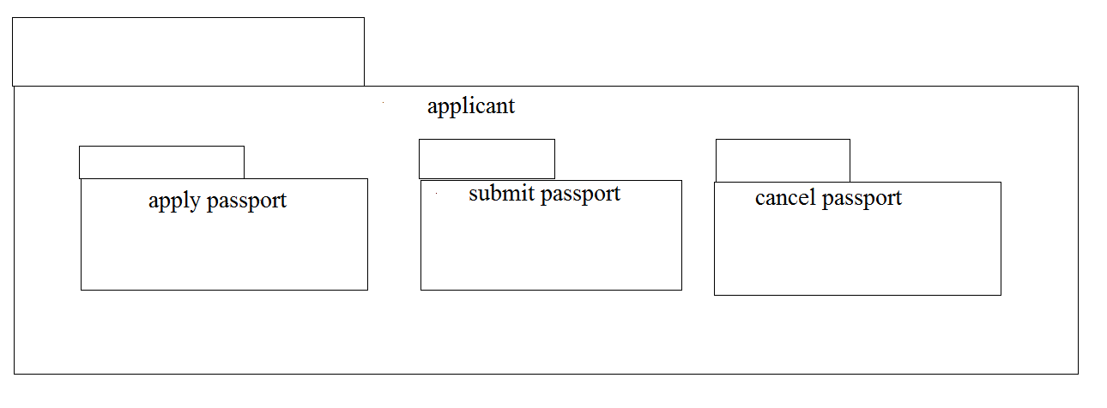

Ex:No:02 | BOOK BANK REGISTRATION SYSTEM
Date:

USE CASE DIAGRAM:
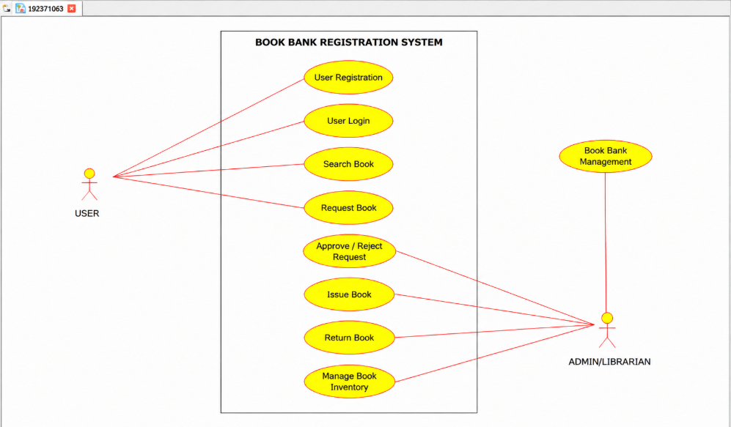

CLASS DIAGRAM:
This diagram consists of the following classes, attributes and their operations.
CLASSES | ATTRIBTES | OPERATIONS
Computer | Student record,  Book list | Enter issue(),  Check availability()
Stud | Student details | Request for books(),  Register()
Admin | Student details,  Book list | Verify student id(),  Issue books()

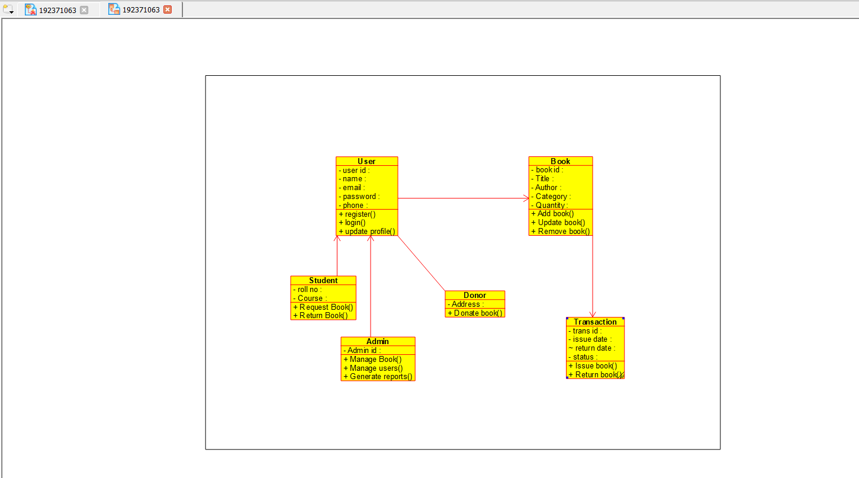

ACTIVITY DIAGRAM:
This diagram will have the activities as Start point, End point, Decision boxes as given below:
Activities: Verify id, return books, request for books, enter book issue details in system, issue books
Decision box: Check availability of books whether it is present or not.

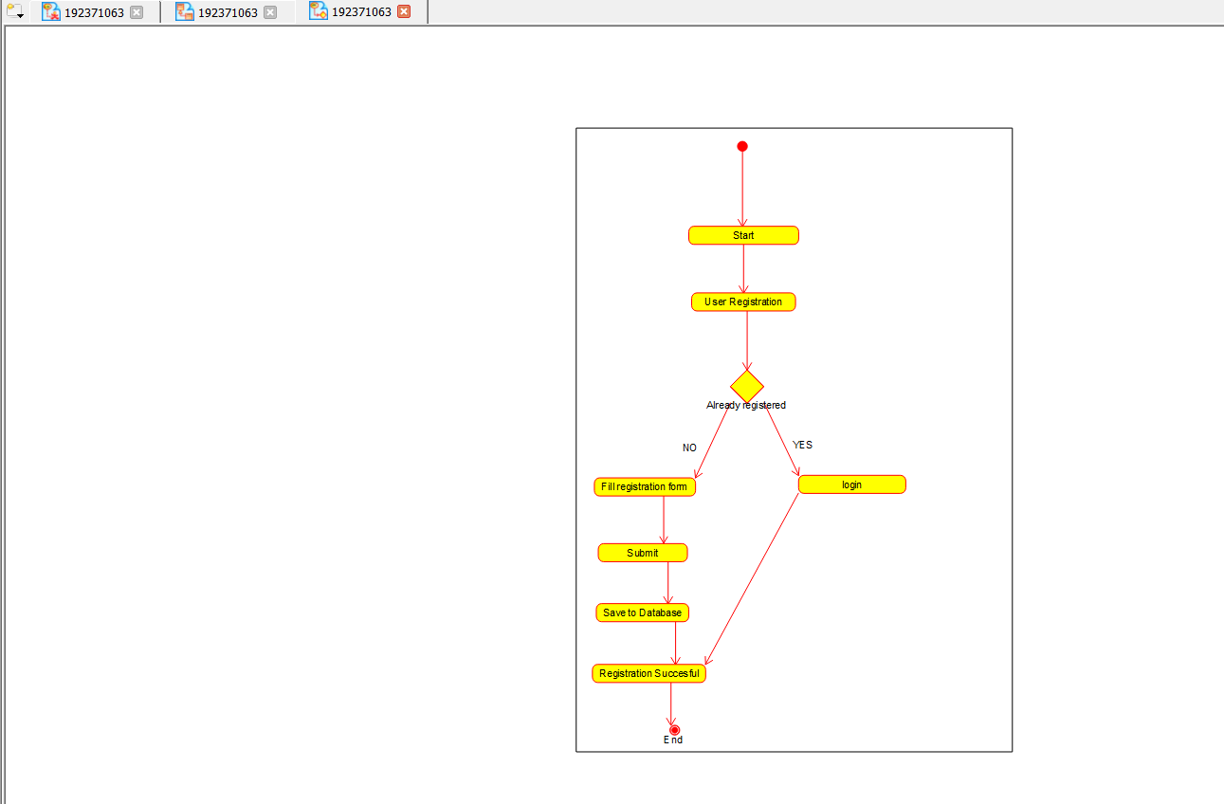

SEQUENCE DIAGRAM:
This diagram consists of the objects, messages and return messages.
Object: Stud, admin, computer

COLLABORATION DIAGRAM:
This diagram contains the objects and actors. This will be obtained by the completion of the sequence diagram and pressing the F5 key.

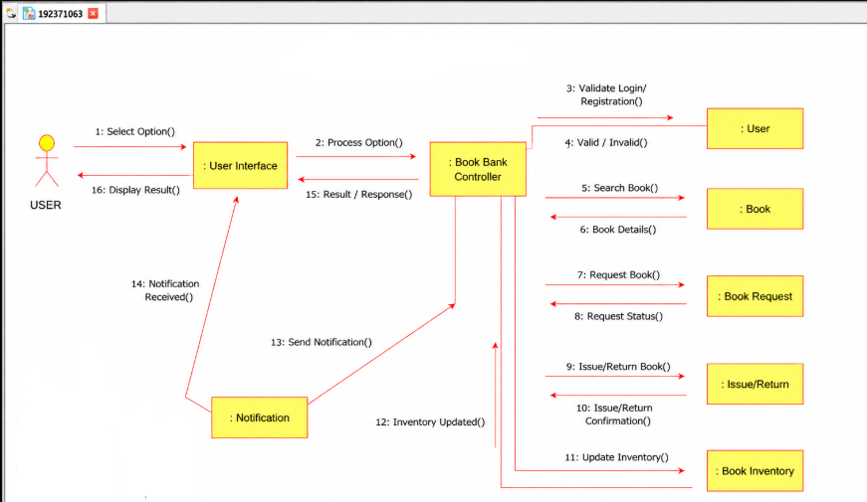

STATE CHART DIAGRAM
The purpose of state chart diagram is to understand the algorithm involved in performing a method. It is also called as state diagram. A state is represented as a round box, which may contain one or more compartments. An initial state is represented as small dot. An final state is represented as circle surrounding a small dot.

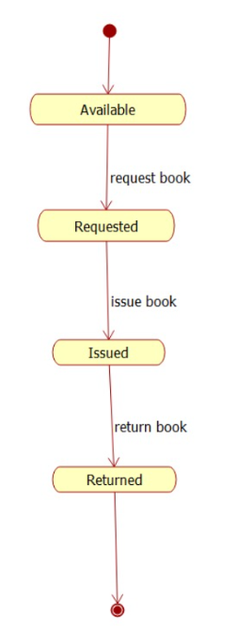

COMPONENT DIAGRAM
The component diagram's main purpose is to show the structural relationships between the components of a system. It is represented by boxed figure. Dependencies are represented by communication association
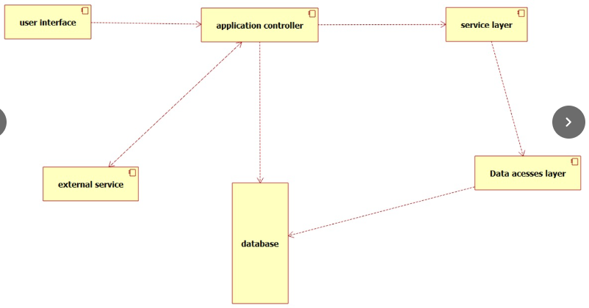

DEPLOYMENT DIAGRAM
A deployment diagram in the unified modeling language serves to model the physical deployment of artifacts on deployment targets. Deployment diagrams show "the allocation of artifacts to nodes according to the Deployments defined between them. It is represented by 3- dimentional box. Dependencies are represented by communication association
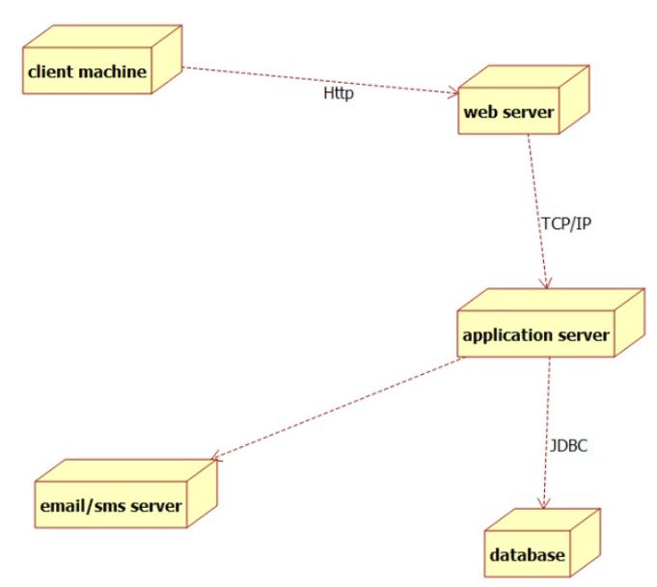

PACKAGE DIAGRAM:
A package diagram in unified modeling language that depicts the dependencies between the packages that make up a model. A Package Diagram (PD) shows a grouping of elements in the OO model, and is a Cradle extension to UML. PDs can be used to show groups of classes in Class Diagrams (CDs), groups of components or processes in Component Diagrams (CPDs), or groups of processors in Deployment Diagrams (DPDs).
There are three types of layer. They are
o User interface layer

o Domain layer

o Technical services layer
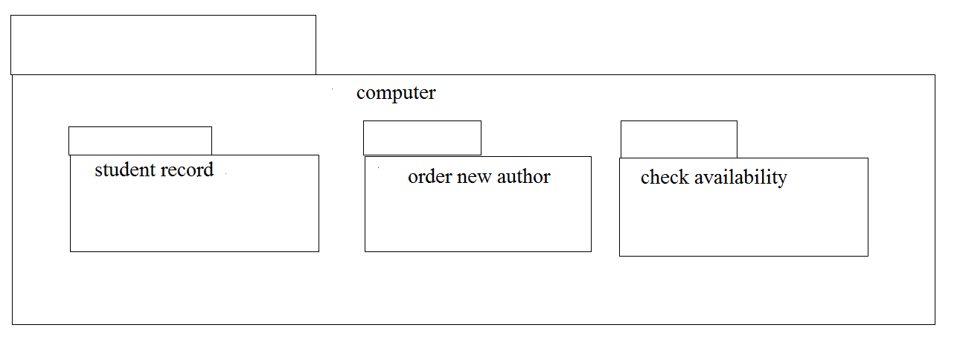
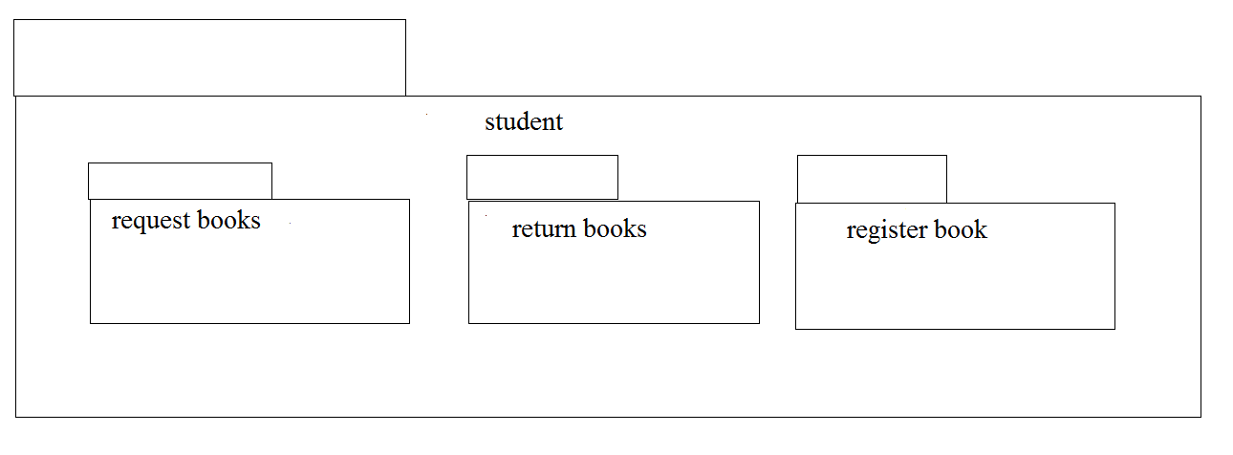
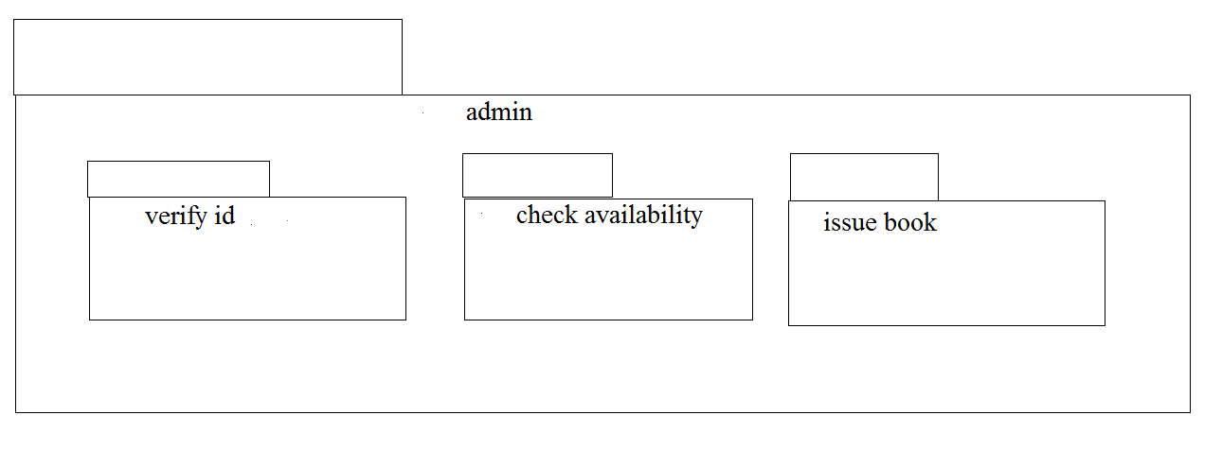
EX NO: 3 | EXAM REGISTRATION SYSTEM
DATE:

USE CASE DIAGRAM:
This diagram will contain the actors, use cases which are given below
Actors: Student, educational officer..
Use case: Student details, student photo, student proof submission of proof ,verification of proof, payment of fees, issue of hall ticket.

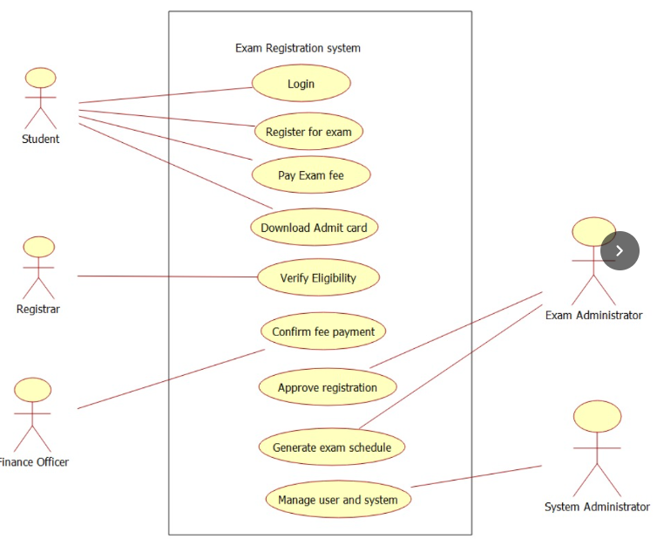

CLASS DIAGRAM:
This diagram consists of the following classes, attributes and their operations

CLASSES | ATTRIBUTES | OPERATIONS
Central educational system | Student details | Print hall ticket(),  Issue hall ticket()
Stud | Submit details,  Submit photo | Payment of fees()
Edu officer | Enter details | Issue hall ticket(),  Verify proof()
.
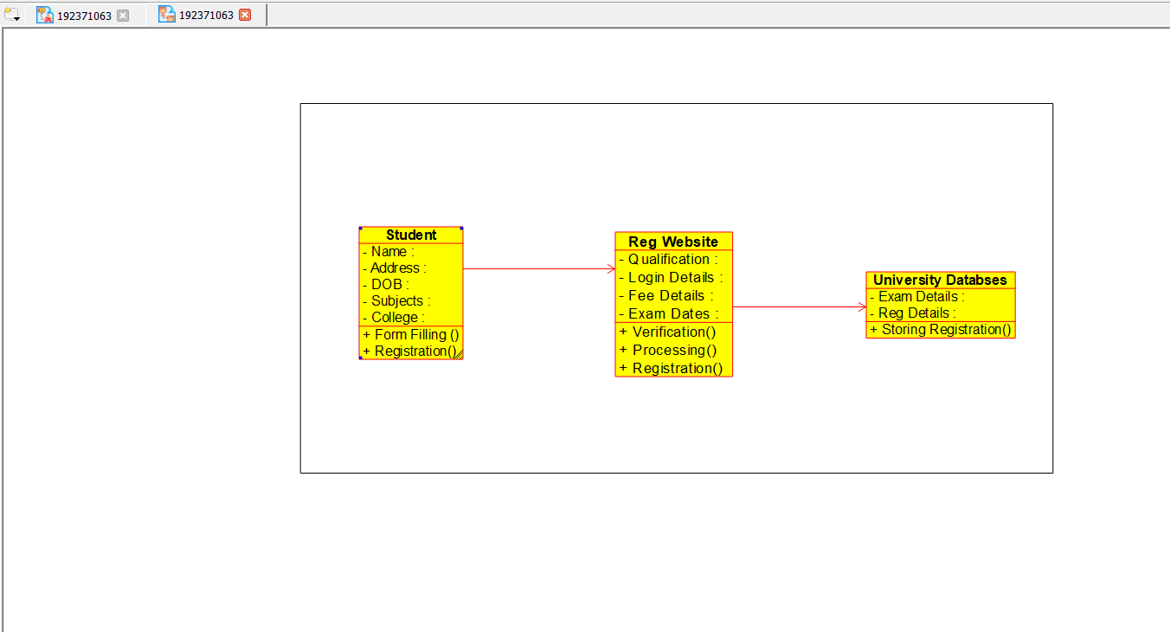

ACTIVITY DIAGRAM:
This diagram will have the activities as Start point, End point, Decision boxes as given below:
Activities: Enter student details , submit student proof and photo, payment of fees, issue of hall ticket.
Decision box: Verification of proof.

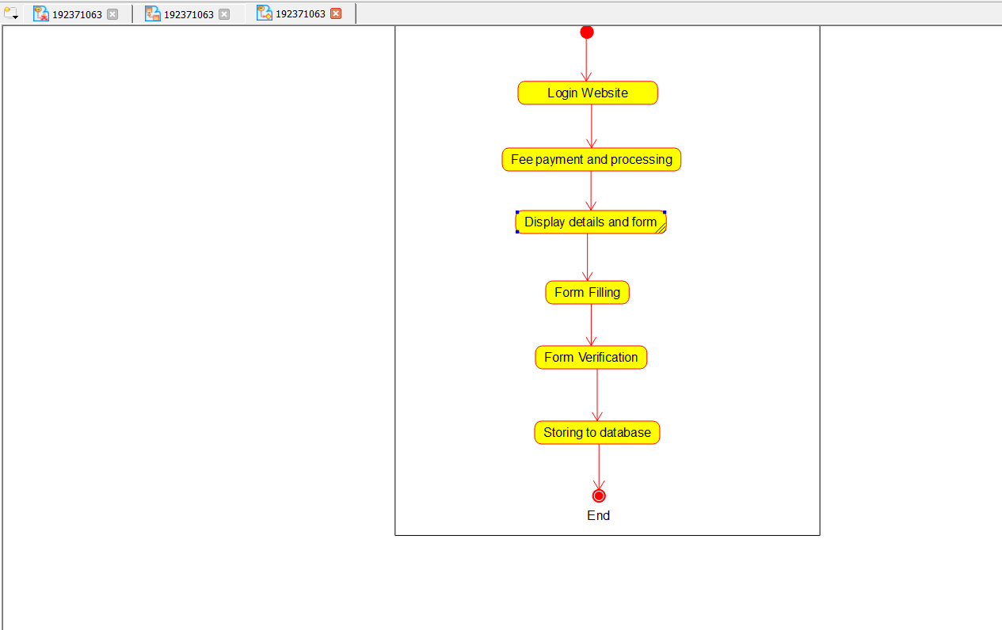

SEQUENCE DIAGRAM:
This diagram consists of the objects, messages and return messages.
Object: student, educational officer, central education system.

COLLABORATION DIAGRAM:
This diagram contains the objects and actors. This will be obtained by the completion of the sequence diagram and pressing the F5 key.

STATE CHART DIAGRAM:
The purpose of state chart diagram is to understand the algorithm involved in performing a method. It is also called as state diagram. A state is represented as a round box, which may contain one or more compartments. An initial state is represented as small dot. A final state is represented as circle surrounding a small dot.
STATE CHART DIAGRAM:
COMPONENT DIAGRAM:
The component diagram's main purpose is to show the structural relationships between the components of a system. It is represented by boxed figure. Dependencies are represented by communication association

DEPLOYMENT DIAGRAM:
A deployment diagram in the unified modeling language serves to model the physical deployment of artifacts on deployment targets. Deployment diagrams show "the allocation of artifacts to nodes according to the Deployments defined between them. It is represented by 3- dimentional box. Dependencies are represented by communication association.

PACKAGE DIAGRAM:
A package diagram in unified modeling language that depicts the dependencies between the packages that make up a model. A Package Diagram (PD) shows a grouping of elements in the OO model, and is a Cradle extension to UML. PDs can be used to show groups of classes in Class Diagrams (CDs), groups of components or processes in Component Diagrams (CPDs), or groups of processors in Deployment Diagrams (DPDs).
There are three types of layer. They are
o User interface layer

o Domain layer

o Technical services layer

EX:NO:4 | STOCK MAINTAINANCE SYSTEM
DATE:

USE CASE DIAGRAM:
This diagram will contain the actors, use cases which are given below
Actors: Customer, Stock dealer, central stock system.
Use case: purchase order, verification of order, payment ,delivery of items.

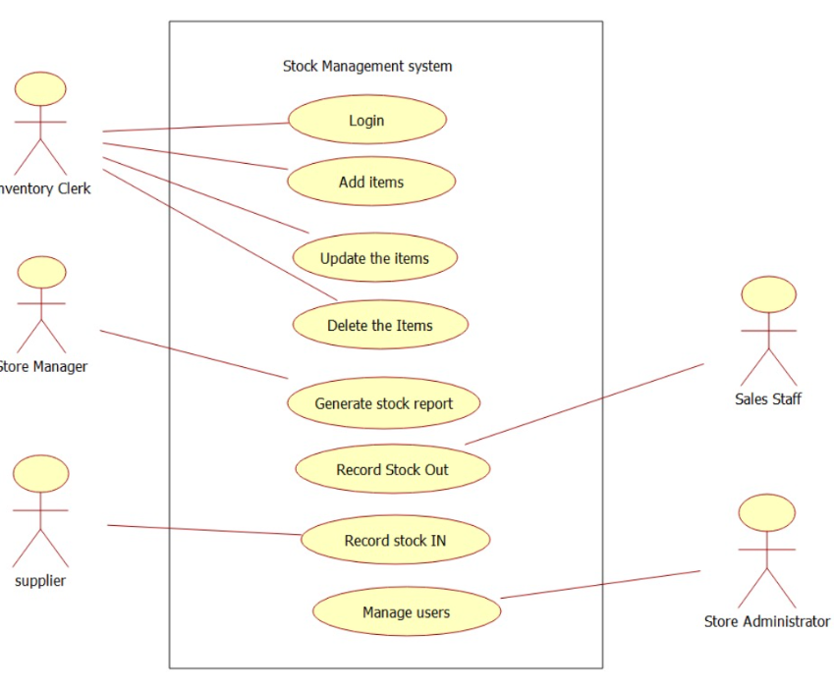

CLASS DIAGRAM:
This diagram consists of the following classes, attributes and their operations.
CLASSES | ATTRIBUTES | OPERATIONS
Central stock system | Store stock details | Print bill()
Stock dealer | Take order | Deliver item()
Customer | Place order | Payment()

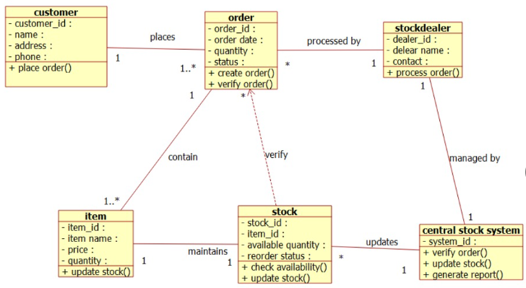

ACTIVITY DIAGRAM:
This diagram will have the activities as Start point ,End point, Decision boxes as given below:
Activities: Purchase order, payment , delivery of items.
Decision box: Valid or not

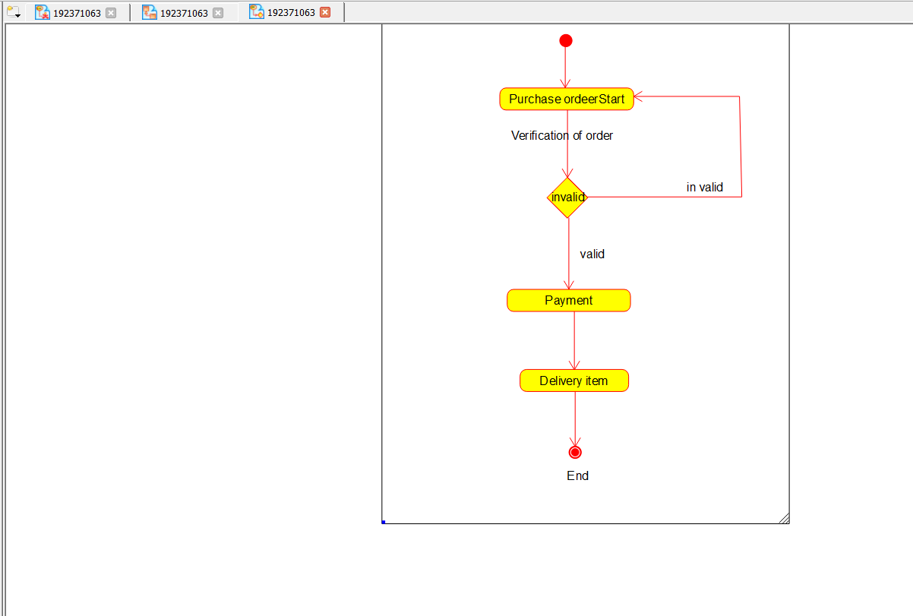

SEQUENCE DIAGRAM:
This diagram consists of the objects, messages and return messages.
Object: Customer, Stock dealer, Central stock system

COLLABORATION DIAGRAM:
This diagram contains the objects and actors. This will be obtained by the completion of the sequence diagram and pressing the F5 key.
STATE CHART DIAGRAM:
The purpose of state chart diagram is to understand the algorithm involved in performing a method. It is also called as state diagram. A state is represented as a round box, which may contain one or more compartments. An initial state is represented as small dot. A final state is represented as circle surrounding a small dot.

COMPONENT DIAGRAM:
The component diagram's main purpose is to show the structural relationships between the components of a system. It is represented by boxed figure. Dependencies are represented by communication association

DEPLOYMENT DIAGRAM:
A deployment diagram in the unified modeling language serves to model the physical deployment of artifacts on deployment targets. Deployment diagrams show "the allocation of artifacts to nodes according to the Deployments defined between them. It is represented by 3- dimentional box. Dependencies are represented by communication association.

PACKAGE DIAGRAM:
A package diagram in unified modeling language that depicts the dependencies between the packages that make up a model. A Package Diagram (PD) shows a grouping of elements in the OO model, and is a Cradle extension to UML. PDs can be used to show groups of classes in Class Diagrams (CDs), groups of components or processes in Component Diagrams (CPDs), or groups of processors in Deployment Diagrams (DPDs).
There are three types of layer. They are
o User interface layer

o Domain layer

o Technical services layer

EX NO:5 | ONLINE COURSE RESERVATION SYSTEM
DATE:

USE CASE DIAGRAM:
This diagram will contain the actors, use cases which are given below
Actors: Student, University.
Use case: Browse course, select course, register, submit details, verify details, pay fees, enroll student.

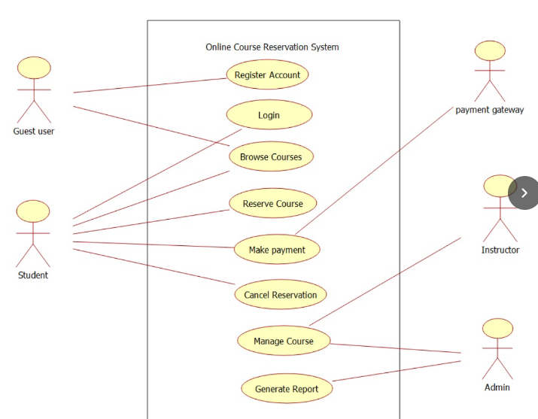

CLASS DIAGRAM:
This diagram consists of the following classes, attributes and their operations.
CLASSES | ATTRIBUTES | OPERATIONS
Central management system | Store details | Verify()
Student | Name and address | Browse()
University | Store details | Verify()

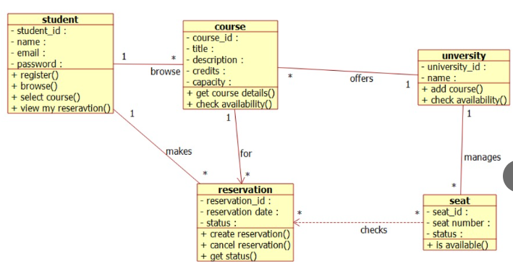

ACTIVITY DIAGRAM:
This diagram will have the activities as Start point ,End point, Decision boxes as given below:
Activities: Browse course, select course, register course, submit details
Decision box: check availability or not.

SEQUENCE DIAGRAM:
This diagram consists of the objects, messages and return messages.
Object: Student, University, Central management system

COLLABORATION DIAGRAM:
This will be obtained by the completion of the sequence diagram and pressing the F5 This diagram contains the objects and actors key.

STATE CHART DIAGRAM:
It is a technique to describe the behavior of the system. It describes all the possible states that a particular object gets into the object oriented technique. State diagram are drawn for a single class to show to the lifetime behaviour of a single objects

COMPONENT DIAGRAM:
The component diagram is represented by figure dependency and it is a graph of design of figure dependency. The component diagram's main purpose is to show the structural relationships between the components of a systems. It is represented by boxed figure. Dependencies are represented by communication association

DEPLOYMENT DIAGRAM:
A deployment diagram in the unified modeling language serves to model the physical deployment of artifacts on deployment targets. Deployment diagrams show "the allocation of artifacts to nodes according to the Deployments defined between them. It is represented by 3- dimentional box. Dependencies are represented by communication association.

PACKAGE DIAGRAM:
A package diagram in unified modeling language that depicts the dependencies between the packages that make up a model. A Package Diagram (PD) shows a grouping of elements in the OO model, and is a Cradle extension to UML. PDs can be used to show groups of classes in Class Diagrams (CDs), groups of components or processes in Component Diagrams (CPDs), or groups of processors in Deployment Diagrams (DPDs).
There are three types of layer. They are
o User interface layer

o Domain layer

o Technical services layer

EX NO:6 | E-TICKETING
DATE:

USE CASE DIAGRAM:

This diagram will contain the actors, use cases which are given below
Actors: Passenger, Railway reservation system..
Use case: Status, reservation, cancellation, enter the train number, enter the number of seats, availability of seats, acceptance of ticket.

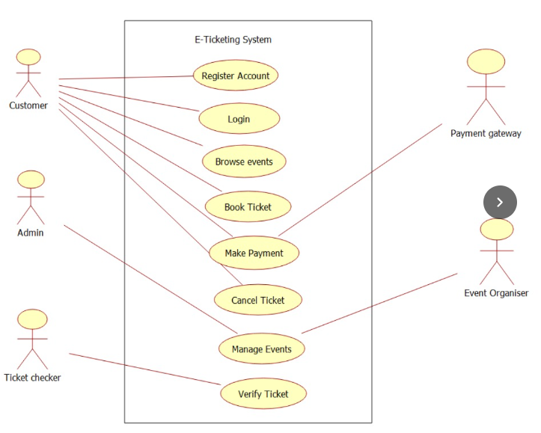

CLASS DIAGRAM:
This diagram consists of the following classes, attributes and their operations.
CLASSES | ATTRIBUTES | OPERATIONS
Central computer | Train name,  Passenger name | Reservation(), login()
Passenger | Passenger age | Login()
Railway reservation system | Train number | Cancellation()

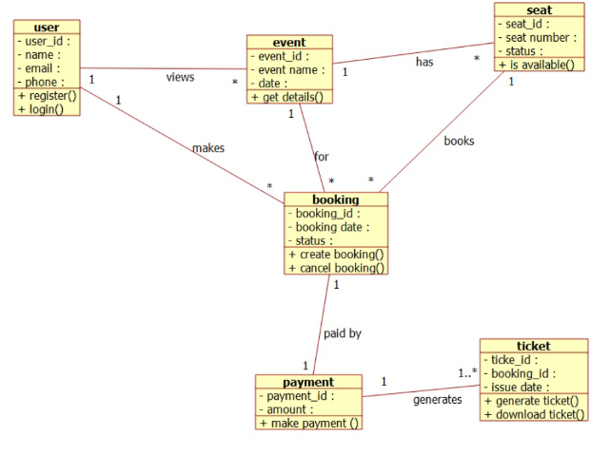

ACTIVITY DIAGRAM:

This diagram will have the activities as Start point, End point, Decision boxes as given below:
Activities: enter the train number, enter the number of seats, acceptance of ticket, accept seat.
Decision box: Check availability of seats whether it is present or not.
SEQUENCE DIAGRAM:
This diagram consists of the objects, messages and return messages.
Object: Passenger, Railway reservation system, Central computer.

COLLABORATION DIAGRAM:
This diagram contains the objects and actors. This will be obtained by the completion of the sequence diagram and pressing the F5 key.

STATE CHART DIAGRAM:
It is a technique to describe the behavior of the system. It describes all the possible states that a particular object gets into the object oriented technique. State diagram are drawn for a single class to show to the lifetime behaviour of a single objects

COMPONENT DIAGRAM:
The component diagram is represented by figure dependency and it is a graph of design of figure dependency. The component diagram's main purpose is to show the structural relationships between the components of a systems. It is represented by boxed figure. Dependencies are represented by communication association
DEPLOYMENT DIAGRAM:
A deployment diagram in the unified modeling language serves to model the physical deployment of artifacts on deployment targets. Deployment diagrams show "the allocation of artifacts to nodes according to the Deployments defined between them. It is represented by 3- dimentional box. Dependencies are represented by communication association.
PACKAGE DIAGRAM:
A package diagram in unified modeling language that depicts the dependencies between the packages that make up a model. A Package Diagram (PD) shows a grouping of elements in the OO model, and is a Cradle extension to UML. PDs can be used to show groups of classes in Class Diagrams (CDs), groups of components or processes in Component Diagrams (CPDs), or groups of processors in Deployment Diagrams (DPDs).
There are three types of layer. They are
o User interface layer

o Domain layer

o Technical services layer

EX NO:07 | CREDIT CARD PROCESSING SYSTEM
DATE:

USE CASE DIAGRAM:
This diagram will contain the actors, use cases which are given below
Actors: Cardholder, Cashier, Central system.
Use case: Receive bill, Give card, Enter card number, Enter amount, Transaction, Receive Receipt.

CLASS DIAGRAM:
This diagram consists of the following classes, attributes and their operations.
CLASSES | ATTRIBUTES | OPERATIONS
Central system | product name,  product details | Print bill(),  Validate card()
Cashier | Product name,  Cost of the product | Enter amount(),  Swipe card(),  Print bill(),  Deliver product()
Card holder | Item purchased,  Validate card | Give card(),  Sign bill()

ACTIVITY DIAGRAM:
This diagram will have the activities as Start point ,End point, Decision boxes as given below:
Activities: Receive Bill, Give card, Enter the card number, Enter the amount, Transaction, Receive Receipt
Decision box: Verification of card

SEQUENCE DIAGRAM:
This diagram consists of the objects, messages and return messages.
Object: Card Holder,Cashier , Central system

COLLABORATION DIAGRAM:
This diagram contains the objects and actors. This will be obtained by the completion of the sequence diagram and pressing the F5 key.

STATE CHART DIAGRAM:
It is a technique to describe the behavior of the system. It describes all the possible states that a particular object gets into the object oriented technique. State diagram are drawn for a single class to show to the lifetime behaviour of a single objects.

COMPONENT DIAGRAM:
The component diagram is represented by figure dependency and it is a graph of design of figure dependency. The component diagram's main purpose is to show the structural relationships between the components of a systems. It is represented by boxed figure. Dependencies are represented by communication association

DEPLOYMENT DIAGRAM:
A deployment diagram in the unified modeling language serves to model the physical deployment of artifacts on deployment targets. Deployment diagrams show "the allocation of artifacts to nodes according to the Deployments defined between them. It is represented by 3- dimentional box. Dependencies are represented by communication association.

PACKAGE DIAGRAM:
A package diagram in unified modeling language that depicts the dependencies between the packages that make up a model. A Package Diagram (PD) shows a grouping of elements in the OO model, and is a Cradle extension to UML. PDs can be used to show groups of classes in Class Diagrams (CDs), groups of components or processes in Component Diagrams (CPDs), or groups of processors in Deployment Diagrams (DPDs).
There are three types of layer. They are
o User interface layer

o Domain layer

o Technical services layer

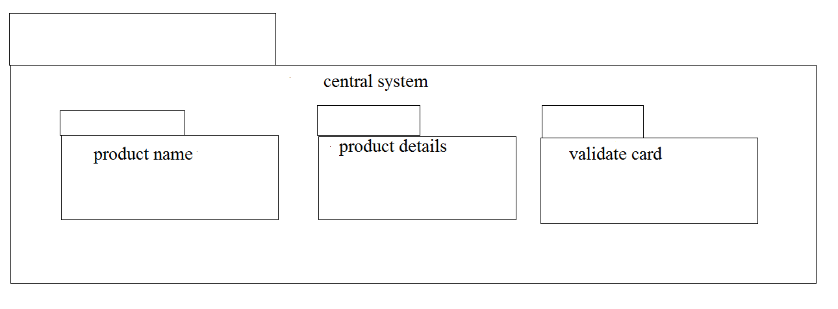
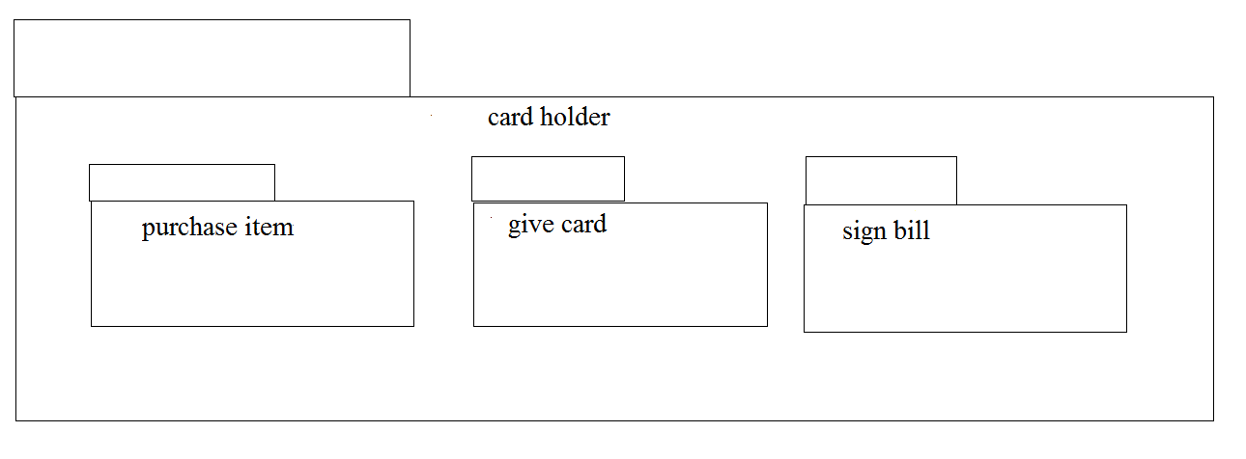
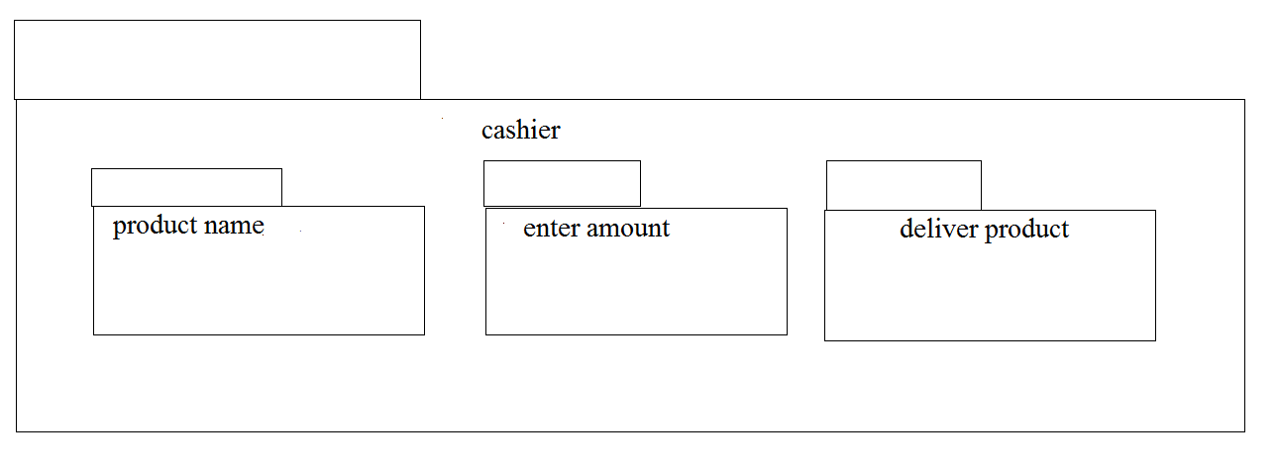

EX:NO:08 | SOFTWARE PERSONNEL MANAGEMENT SYSTEM
DATE:

USECASE DIAGRAM:
This diagram will contain the actors, usecases which are:
ACTORS: Employee, HR, Central System
USECASE: Name and address, qualification, experience, internet, loan, verification

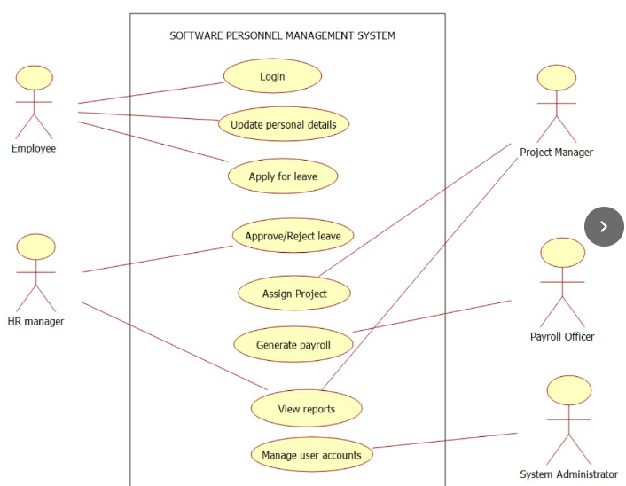

CLASS DIAGRAM:
This diagram consists of the following classes, attributes and their operations.
CLASSES | ATTRIBUTES | OPERATIONS
Central Management System | Employee name  Employee number | Tax()  Loan()
Employee1 | Employee details | Leave taken()
HR | Check details | Loss of pay()

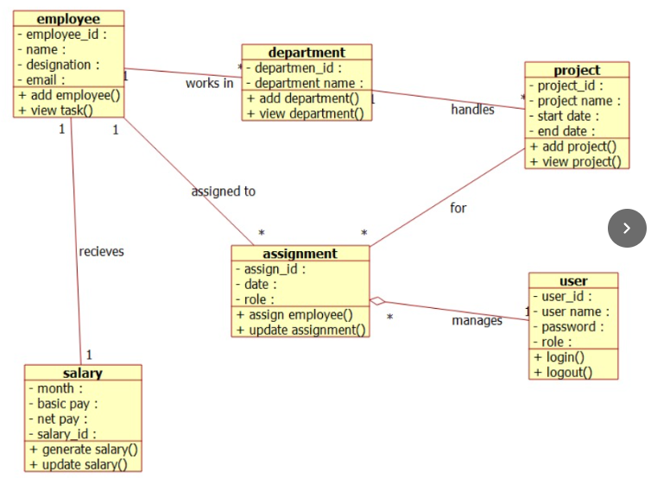

ACTIVITY DIAGRAM:
This diagram will have the activities as start point, end point, decision boxes as:
ACTIVITIES: Enter the option to check, enter the salary, enter the working days, leave taken, loss of pay
DECISION BOX: Option to check

SEQUENCE DIAGRAM:
This diagram consists of the objects, messages and return messages
OBJECT: Employee, HR, Central System

COLLABORATION DIAGRAM:
This diagram contains the objects and actors. This will be obtained by the completing of the sequence diagram and pressing the F5 key

STATECHART DIAGRAM:
It is a technique to describe the behavior of the system. It describes all the possible states that a particular object gets into the object oriented technique. State diagram are drawn for a single class to show to the lifetime behaviour of a single objects.

COMPONENT DIAGRAM:
The component diagram is represented by figure dependency and it is a graph of design of figure dependency. The component diagram's main purpose is to show the structural relationships between the components of a systems. It is represented by boxed figure. Dependencies are represented by communication association

DEPLOYMENT DIAGRAM:
A deployment diagram in the unified modeling language serves to model the physical deployment of artifacts on deployment targets. Deployment diagrams show "the allocation of artifacts to nodes according to the Deployments defined between them. It is represented by 3- dimentional box. Dependencies are represented by communication association.

PACKAGE DIAGRAM:
A package diagram in unified modeling language that depicts the dependencies between the packages that make up a model. A Package Diagram (PD) shows a grouping of elements in the OO model, and is a Cradle extension to UML. PDs can be used to show groups of classes in Class Diagrams (CDs), groups of components or processes in Component Diagrams (CPDs), or groups of processors in Deployment Diagrams (DPDs).
There are three types of layer. They are
o User interface layer

o Domain layer

o Technical services layer
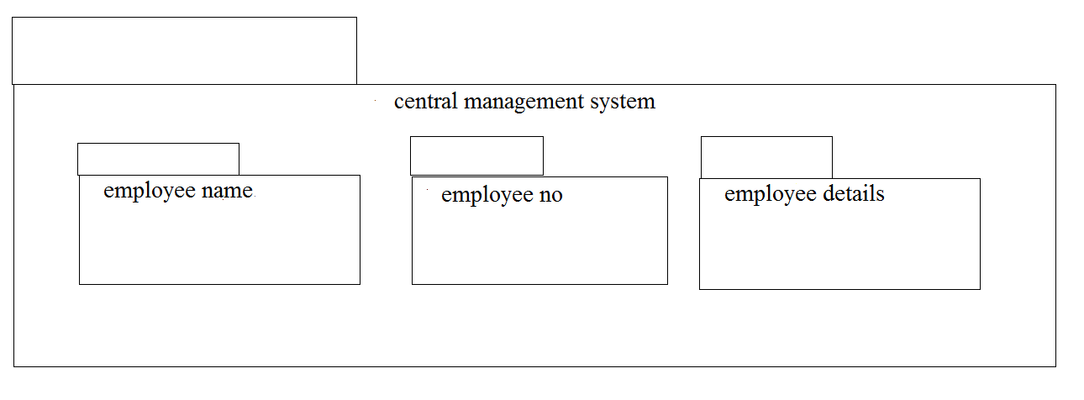
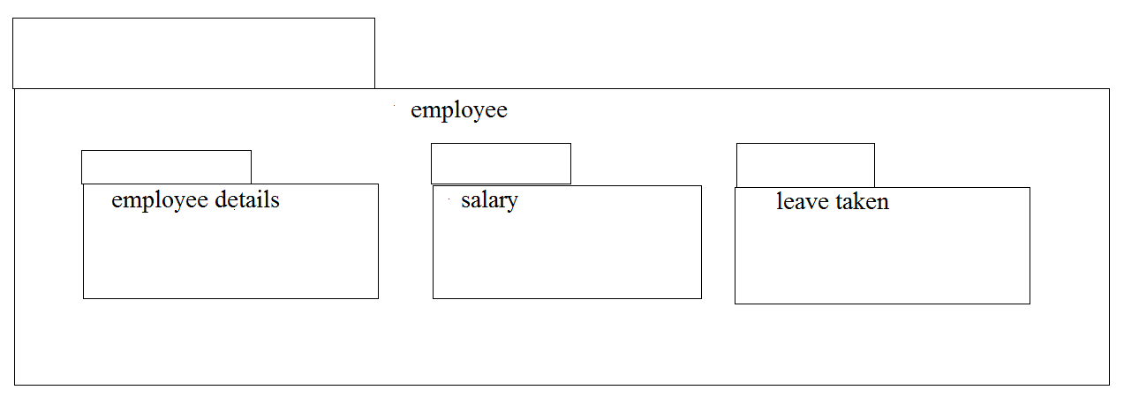
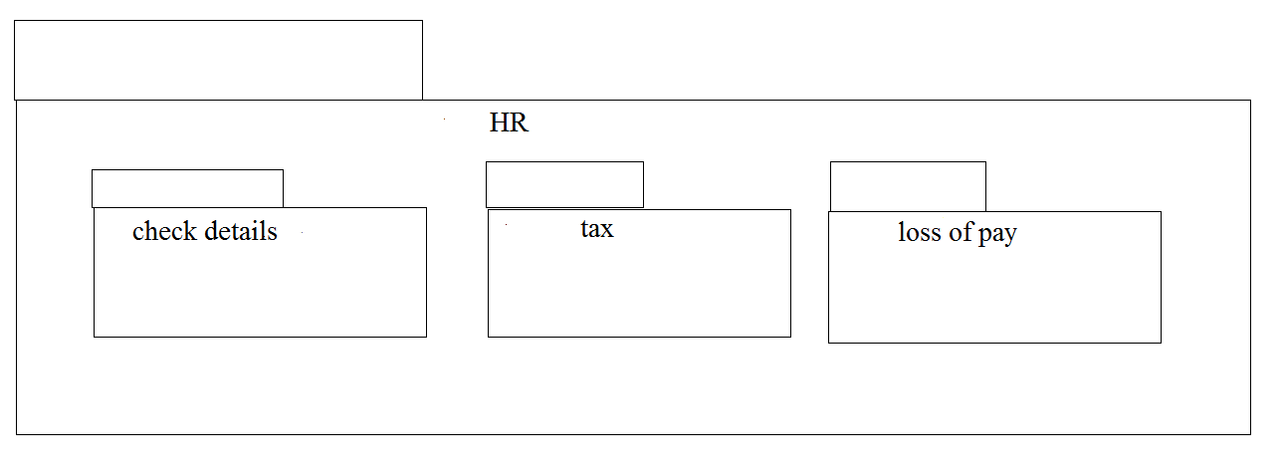

EX.NO:09 | E-BOOK MANAGEMENT SYSTEM
DATE:

USE CASE DIAGRAM:
This diagram will contain the actors, use cases which are given below
Actors: user, e-book management
Use case: login ,search books, download ,pay for the books, logout .

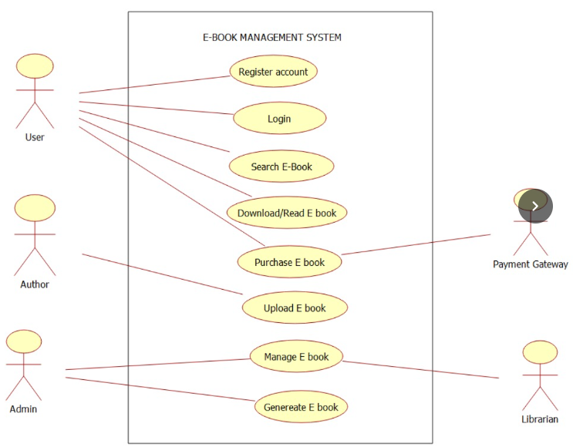

CLASS DIAGRAM:
This diagram consists of the following classes, attributes and their operations.
CLASSES | ATTRIBUTES | OPERATIONS
Internet | Enter id, login, logout | Surf book()
User | Login, logout | Surf book()
E-book management system | verify user | check availability()

ACTIVITY DIAGRAM:
This diagram will have the activities as Start point ,End point, Decision boxes as given below:
Activities: Search for the e-book site,search for the book,download book
Decision box: check availability

SEQUENCE DIAGRAM:
This diagram consists of the objects, messages and return messages.
Object: User ,E-book management ,Internet

COLLABORATION DIAGRAM:
This diagram contains the objects and actors. This will be obtained by the completion of the sequence diagram and pressing the F5 key.

STATECHART DIAGRAM:
It is a technique to describe the behavior of the system. It describes all the possible states that a particular object gets into the object oriented technique. State diagram are drawn for a single class to show to the lifetime behaviour of a single objects.

COMPONENT DIAGRAM:
The component diagram is represented by figure dependency and it is a graph of design of figure dependency. The component diagram's main purpose is to show the structural relationships between the components of a systems. It is represented by boxed figure. Dependencies are represented by communication association.

DEPLOYMENT DIAGRAM:
A deployment diagram in the unified modeling language serves to model the physical deployment of artifacts on deployment targets. Deployment diagrams show "the allocation of artifacts to nodes according to the Deployments defined between them. It is represented by 3- dimentional box. Dependencies are represented by communication association

PACKAGE DIAGRAM:
A package diagram in unified modeling language that depicts the dependencies between the packages that make up a model. A Package Diagram (PD) shows a grouping of elements in the OO model, and is a Cradle extension to UML. PDs can be used to show groups of classes in Class Diagrams (CDs), groups of components or processes in Component Diagrams (CPDs), or groups of processors in Deployment Diagrams (DPDs).
There are three types of layer. They are
o User interface layer

o Domain layer

o Technical services layer

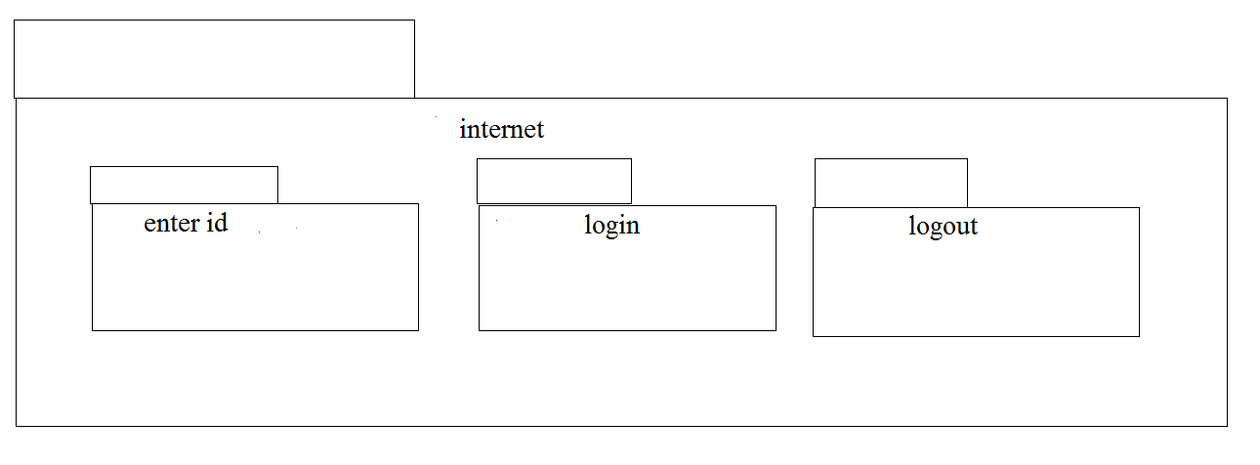
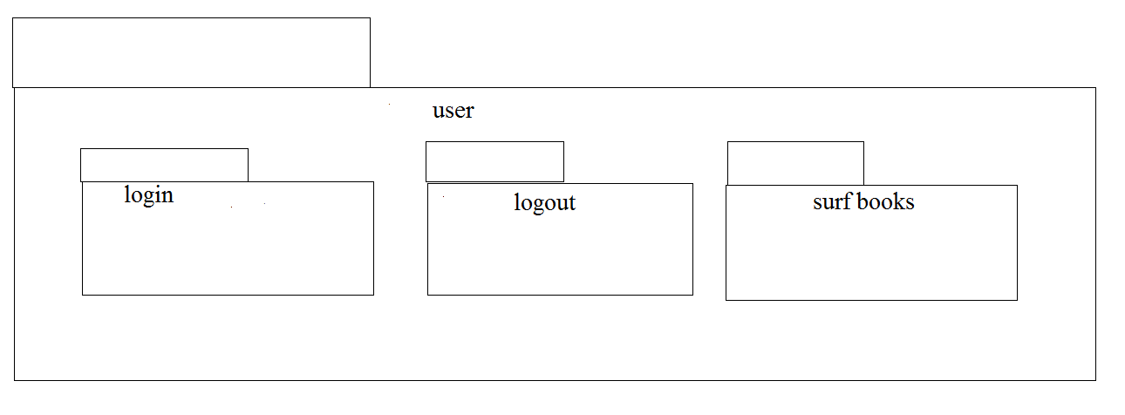
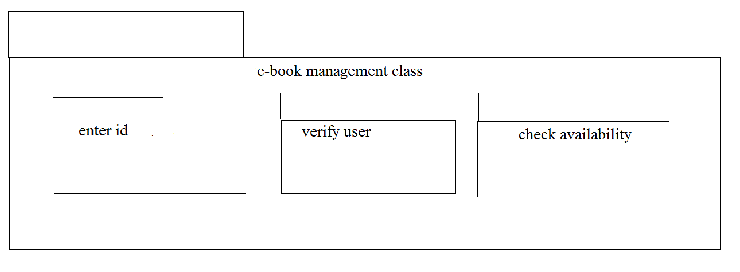
EX:NO:10 | RECRUITMENT SYSTEM
DATE:

USE CASE DIAGRAM:
This diagram will contain the actors, use cases which are given below
Actors: Applicant, HR, Central management system.
Use case: Aptitude, Group discussion, Technical skills, Personal specification, Short list, Result

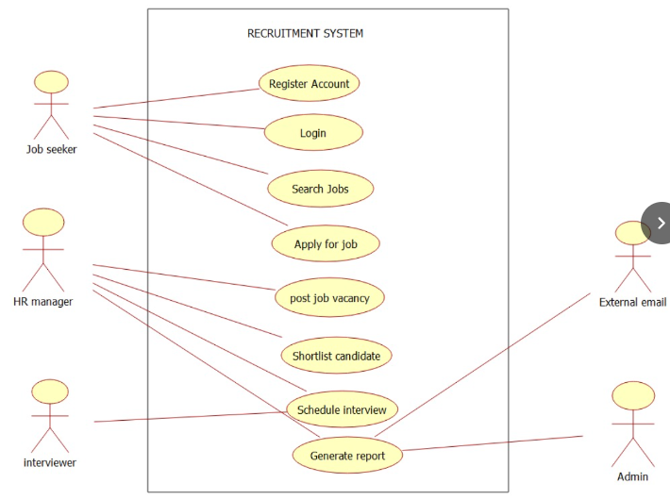

CLASS DIAGRAM:
This diagram consists of the following classes, attributes and their operations.
CLASSES | ATTRIBUTES | OPERATIONS
Candidate | Name, qualification | Verify()
HR | Verification, resume | Select()
Central system | Store, update | Update()

ACTIVITY DIAGRAM:
This diagram will have the activities as Start point ,End point, Decision boxes as given below:
Activities: Aptitude, Group discussion ,Technical skills,HR
Decision box: Verification of the qualities

SEQUENCE DIAGRAM:
This diagram consists of the objects, messages and return messages.
Object: Candidate, HR, Central system

COLLABORATION DIAGRAM:
This diagram contains the objects and actors. This will be obtained by the completion of the sequence diagram and pressing the F5 key.

STATE CHART DIAGRAM:
It is a technique to describe the behavior of the system. It describes all the possible states that a particular object gets into the object oriented technique. State diagram are drawn for a single class to show to the lifetime behaviour of a single objects

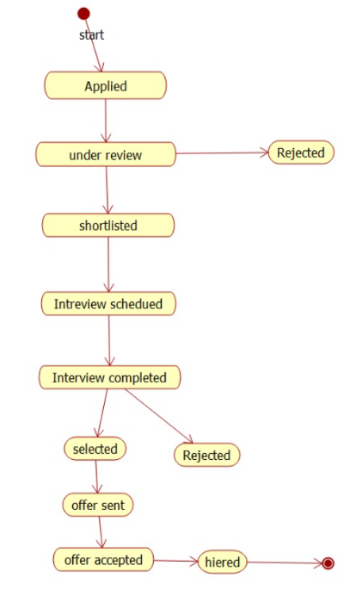

COMPONENT DIAGRAM:
The component diagram is represented by figure dependency and it is a graph of design of figure dependency. The component diagram's main purpose is to show the structural relationships between the components of a systems. It is represented by boxed figure. Dependencies are represented by communication association.

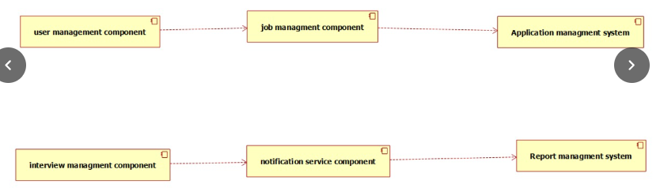
DEPLOYMENT DIAGRAM:
A deployment diagram in the unified modeling language serves to model the physical deployment of artifacts on deployment targets. Deployment diagrams show "the allocation of artifacts to nodes according to the Deployments defined between them. It is represented by 3- dimentional box. Dependencies are represented by communication association

PACKAGE DIAGRAM:
A package diagram in unified modeling language that depicts the dependencies between the packages that make up a model. A Package Diagram (PD) shows a grouping of elements in the OO model, and is a Cradle extension to UML. PDs can be used to show groups of classes in Class Diagrams (CDs), groups of components or processes in Component Diagrams (CPDs), or groups of processors in Deployment Diagrams (DPDs).
There are three types of layer. They are
o User interface layer

o Domain layer

o Technical services layer

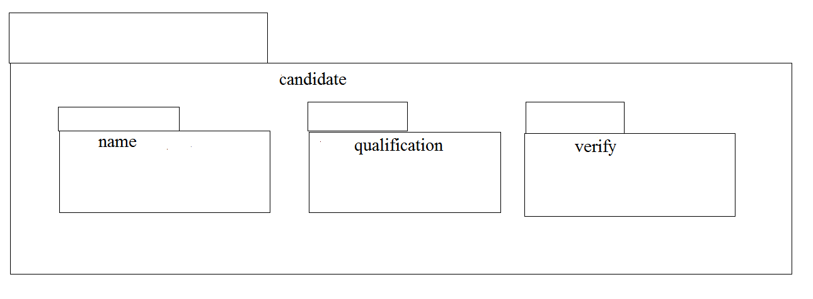
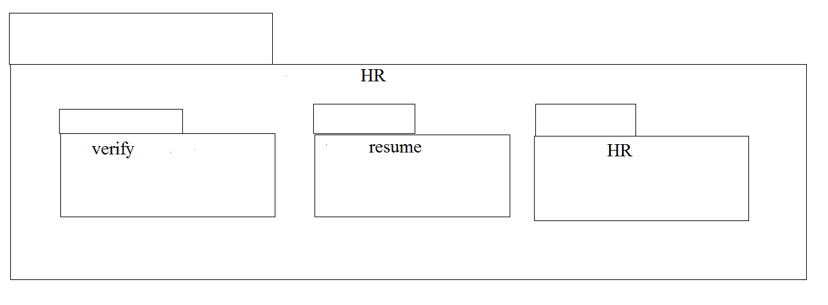
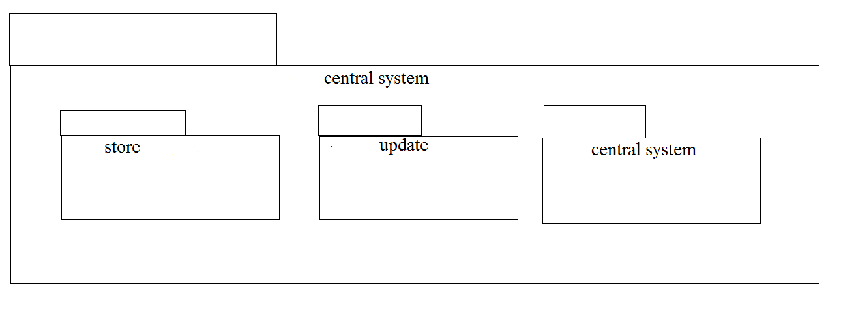

EX:NO:11 | CONFERENCE MANAGEMENT SYSTEM
DATE:

USE CASE DIAGRAM:

This diagram will contain the actors, use cases which are given below
Actors: Member, Organizer, Central system
Use case: planning, invite delegates, allocate seats, presenting paper, prize distribution

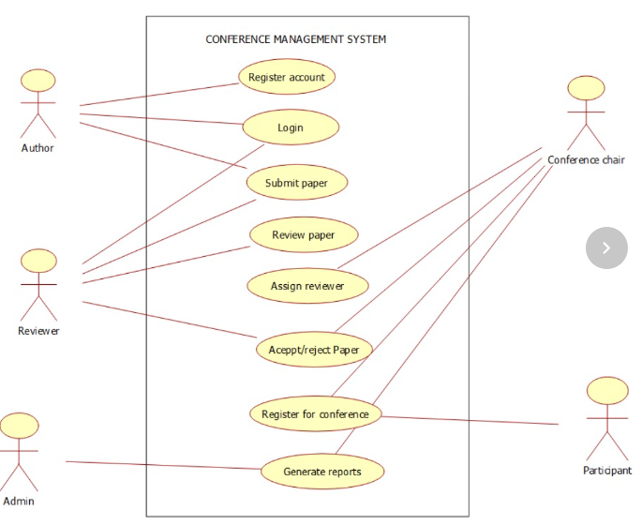

CLASS DIAGRAM:

This diagram consists of the following classes, attributes and their operations

CLASSES | ATTRIBUTES | OPERATIONS
Member | Name, id | Presenting paper()
Organizer | Member details | Allocating seats()
Central management system | Member details | Updating()

ACTIVITY DIAGRAM:
This diagram will have the activities as Start point ,End point, Decision boxes as given below:
Activities: Invite delegates, Allocate seats, Presenting paper, Choose the winner
Decision box: Whether it is reserved or not, Whether the presentation is good or not

SEQUENCE DIAGRAM:
This diagram consists of the objects, messages and return messages.
Object: Member, Organiser, Central management system

COLLABORATION DIAGRAM:
This diagram contains the objects and actors. This will be obtained by the completion of the sequence diagram and pressing the F5 key.

COMPONENT DIAGRAM:
The component diagram is represented by figure dependency and it is a graph of design of figure dependency. The component diagram's main purpose is to show the structural relationships between the components of a systems. It is represented by boxed figure. Dependencies are represented by communication association.

DEPLOYMENT DIAGRAM:
A deployment diagram in the unified modeling language serves to model the physical deployment of artifacts on deployment targets. Deployment diagrams show "the allocation of artifacts to nodes according to the Deployments defined between them. It is represented by 3- dimentional box. Dependencies are represented by communication association

PACKAGE DIAGRAM:
A package diagram in unified modeling language that depicts the dependencies between the packages that make up a model. A Package Diagram (PD) shows a grouping of elements in the OO model, and is a Cradle extension to UML. PDs can be used to show groups of classes in Class Diagrams (CDs), groups of components or processes in Component Diagrams (CPDs), or groups of processors in Deployment Diagrams (DPDs). There are three types of layer. They are
o User interface layer

o Domain layer

o Technical services layer
EX:NO:12 | FOREIGN TRADING SYSTEM
DATE:

USE CASE DIAGRAM:
This diagram will contain the actors, use cases which are given below
Actors: Customer, Supplier, Custom officer
Use case: Order of product, Quantity, Specify the amount

CLASS DIAGRAM:
This diagram consists of the following classes, attributes and their operations.
CLASSES | ATTRIBUTES | OPERATIONS
Trading management system | Verify product | Transport()
Customer | Quality | Payment()
Supplier | Product supply | Money transfer()

ACTIVITY DIAGRAM:
This diagram will have the activities as Start point ,End point, Decision boxes as given below:
Activities: Order of the product, Specify amount, Payment, Money transfer
Decision box: Check for availability

SEQUENCE DIAGRAM:
This diagram consists of the objects, messages and return messages.
Object: Customer, Supplier, Trading management system

COLLABORATION DIAGRAM:
This diagram contains the objects and actors. This will be obtained by the completion of the sequence diagram and pressing the F5 key.

STATECHART DIAGRAM:
It is a technique to describe the behavior of the system. It describes all the possible states that a particular object gets into the object oriented technique. State diagram are drawn for a single class to show to the lifetime behaviour of a single objects

COMPONENT DIAGRAM:
The component diagram is represented by figure dependency and it is a graph of design of figure dependency. The component diagram's main purpose is to show the structural relationships between the components of a systems. It is represented by boxed figure. Dependencies are represented by communication association.

DEPLOYMENT DIAGRAM:
A deployment diagram in the unified modeling language serves to model the physical deployment of artifacts on deployment targets. Deployment diagrams show "the allocation of artifacts to nodes according to the Deployments defined between them. It is represented by 3- dimentional box. Dependencies are represented by communication association

PACKAGE DIAGRAM:
A package diagram in unified modeling language that depicts the dependencies between the packages that make up a model. A Package Diagram (PD) shows a grouping of elements in the OO model, and is a Cradle extension to UML. PDs can be used to show groups of classes in Class Diagrams (CDs), groups of components or processes in Component Diagrams (CPDs), or groups of processors in Deployment Diagrams (DPDs).

There are three types of layer. They are

o User interface layer

o Domain layer

o Technical services layer

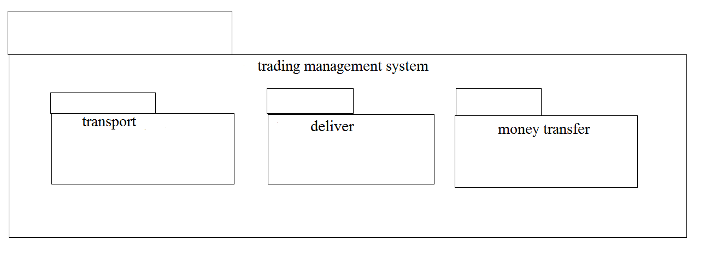
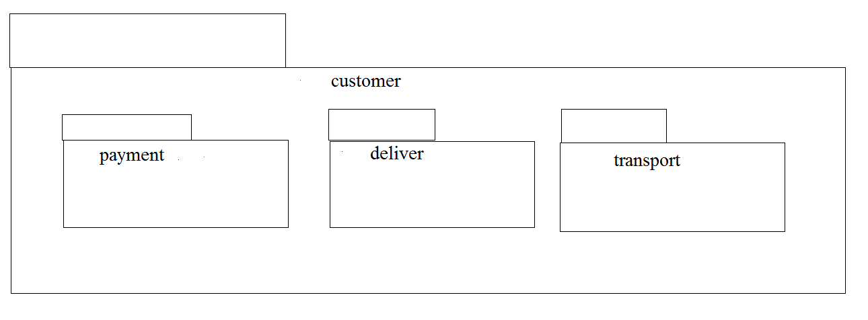
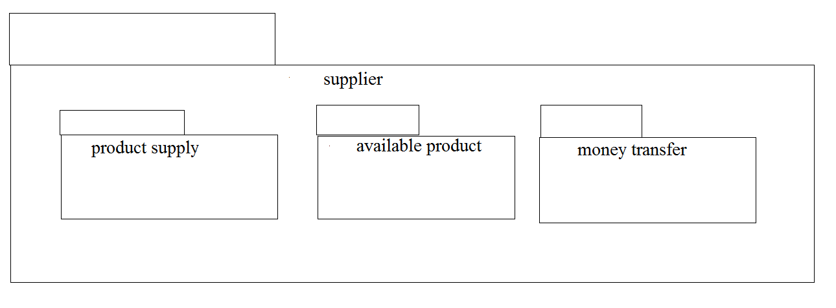

Ex.no 13 | BPO MANAGEMENT SYSTEM
Date:

USECASE DIAGRAM:
This diagram will contain the attributes as start point, end point, decision box as given below
ACTORS: Purchase product, Server, Central system
USECASE: Product, Voice, Non-Voice, Indian office, Employee, Feedback.

CLASS DIAGRAM:
This Diagram consists of the following classes, attributes and their operations.
CLASSES | ATTRIBUTES | OPERATIONS
Central System | Store, update | Storing(), updating()
Dealer | Employee name | Delivery()
Customer | Details | Feedback()

ACTIVITY DIAGRAM:
This diagram will contain the activities as start point, end point, decision boxes as given below
ACTIVITIES: Purchase Product, On call, On chat
DECISION BOX: Option to check

SEQUENCE DIAGRAM:
This diagram consists of the objects, messages and return messages
Object: Customer, Dealer, Central System

COLLABORATION DIAGRAM:
This diagram contains the objects and actors. This will be obtained by the completion of the sequence diagram and pressing F5 key

STATECHART DIAGRAM:
It is a technique to describe the behavior of the system. It describes all the possible states that a particular object gets into the object oriented technique. State diagram are drawn for a single class to show to the lifetime behaviour of a single objects

COMPONENT DIAGRAM:
The component diagram is represented by figure dependency and it is a graph of design of figure dependency. The component diagram's main purpose is to show the structural relationships between the components of a systems. It is represented by boxed figure. Dependencies are represented by communication association.

DEPLOYMENT DIAGRAM:
A deployment diagram in the unified modeling language serves to model the physical deployment of artifacts on deployment targets. Deployment diagrams show "the allocation of artifacts to nodes according to the Deployments defined between them. It is represented by 3- dimentional box. Dependencies are represented by communication association

PACKAGE DIAGRAM:
A package diagram in unified modeling language that depicts the dependencies between the packages that make up a model. A Package Diagram (PD) shows a grouping of elements in the OO model, and is a Cradle extension to UML. PDs can be used to show groups of classes in Class Diagrams (CDs), groups of components or processes in Component Diagrams (CPDs), or groups of processors in Deployment Diagrams (DPDs).

There are three types of layer. They are
o User interface layer

o Domain layer

o Technical services layer

